ABS State Convention 2019
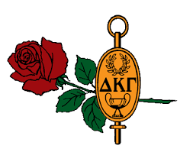
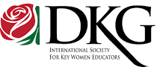
Women in the Arts Exhibit
At the upcoming Alpha Beta State Convention on April 26 - 28, 2019, The Educational Excellence Committee will host the Women in the Arts Exhibit. This gives ABS members the opportunity to show-off their talents. Please submit an application to reserve a space. Share your talent and receive a certificate of participation. The exhibit will be open Friday evening as well as all day on Saturday.
Please complete the form and mail it to Christine Redman, 8731 Brenton Drive in Easton, MD 21601. If you prefer for me to send it to you electronically so you can type it in and send it back, my email address is credman@talbotschools.org and my number is 410-714-0278 if you have any questions.
Registration Form
Name _________________________________________ Chapter _________________________
Address ____________________________________City _____________________Zip _________
Phone: Home _______________ Cell __________________ Email __________________________

I plan to enter the following item(s) in the Women in the Arts Exhibit:
Painting(s) ______ oil _______watercolor ______ other
Description(s) __________________________________________________________________
Needlework _____knitting _____crochet _____embroidery _____sewing _____other
Description(s) __________________________________________________________________
Literary Works _____poetry _____short story _____novel _____other
Description(s) __________________________________________________________________
Miscellaneous arts & crafts _____stained glass _____quilts _____scrapbooks/cards _____baskets

_____mosaics _____calligraphy _____family histories _____jewelry _____other

Description(s) __________________________________________________________________

Music Composition _____ Dance _____ Other ____

Description(s) __________________________________________________________________

SEND COMPLETED FORM BY FRIDAY, MARCH 15, 2019

